-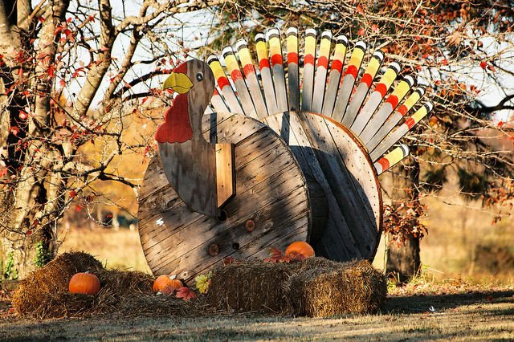
COMMUNITY WATCH - NOVEMBER 2013
United States Attorney’s Office – District of Columbia
A brief summary of community meetings and events that will take place throughout the city in the month of November is listed below. We invite you to become a community watcher and plan to attend and participate in one or more of these exciting opportunities.

November 5, 2013 at 2:00pm-4:00pm: Concerned Black Men Youth Mentoring Program, Achievement Preparatory Academy, 908 Wahler Place SE. Contact: Douglas Klein (703)785-5589. (7D) (Reoccurs on the 12th, and 26th of the month)

November 5, 2013 at 5:30pm: R Street Crime Prevention Presentation, R Street Apartments, 1436 R St. NW. Contact: LaToya Davenport/Roger Kemp (202)671-6552. (3D)

November 6, 2013 at 10:00am: Financial Crimes Against Seniors Presentation, Arthur Capper Senior Building, 900 5th St. SE. Contact: Carolyn Crank/Douglas Klein (202)729-3718. (1D)

November 6, 2013 at 2:00pm: Financial Fraud Abuse Presentation, Delta Towers, 1400 Florida Ave. NE. Contact: Jamila Hodge/Monica Veney (202)698-0144. (5D)

November 6, 2013 at 8:30am-1:00pm: Clergy Ambassador Program, 501 3rd Street, NW. Contact: Ademuyiwa Bamiduro/Lenney Lowe (202)815-8652. (7D)

November 6, 2013 at 3:30pm-5:30pm: East of the River Youth Court Club, Friendship Collegiate Academy, 4095 Minnesota Ave. NW. Contact: Floyd Carson/Leutrell Osborne (202)669-7338. (6D) (Reoccurs on the 1st and 3rd Wednesday of the month)

November 7, 2013 at 9:00am-2:00pm: “Scams Affecting Military Service Members” Presentation, D.C. National Guard Armory, 2001 East Capitol St. SE. Contact: Carolyn Crank/Douglas Klein (703)785-5589. (1D)

November 7, 2013 at 2:00pm-4:00pm: Concerned Black Men Youth Mentoring Program, Friendship Collegiate Chamberlain Campus, 1345 Potomac Ave. SE. Contact: Carolyn Crank/Douglas Klein (202)729-3718. (1D) (Reoccurs on the 2nd and 3rd Monday of the month)

November 8, 2013 at 3:15pm: Internet Safety Presentation, Elliot Hine Middle School, 1830 Constitution Ave. NE. Contact: Carolyn Crank/Douglas Klein (703)785-5589. (1D)

November 12, 2013 at 10:30am: Domestic Violence Presentation, Sibley Plaza, 1140 North Capitol St. NW. Contact: Carolyn Crank/Douglas Klein (202)729-3718. (1D)

November 12, 2013 at 11:00am: Domestic Violence Presentation, Mini Film: “On 2nd Thought” New Park Chester Apartments, 2906 Pomeroy Road SE. Contact: Lenney Lowe/Muyiwa Bamiduro (202)252-7222. (7D)

November 14, 2013 at 11:00am: Elder Abuse Presentation, Samuel Kelsey Senior Apartments, 3322 14th St NW. Contact: LaToya Davenport/Roger Kemp (202)671-6552. (3D)

November 14, 2013 at 2:00pm: Domestic Violence Presentation, Mini Film: “On 2nd Thought”, New Heights Parenting Program, Ballou High School, 3401 4th St. SE. Contact: Lenney Lowe/Muyiwa Bamiduro (202)252-7222. (7D)

November 14, 2013 at 6:00pm-8:00pm: Juvenile Law Enforcement Training, Southeast Whitehouse, 2909 Pennsylvania Ave. SE. Contact: Floyd Carson/Leutrell Osborne (202)698-0884. (6D)

November 16, 2013 at 10:00am-12:00pm: Leadership Academy Explorers, Emergency Preparedness Training Presentation, 555 4th St. NW, Moot Court Room. Contact: Melanie Howard (202)252-6930.

November 18, 2012 at 3:00pm: Security Officer Training, Children’s Hospital, 111 Michigan Ave. NW. Contact: Trena Carrington (202) 252-7312. (4D)

November 18, 2013 at 6:30pm: Domestic Violence Presentation, Mt. Sinai Baptist Church, 1615 Third St. NE. Contact: Monica Veney/Jamila Hodge (202)698-0145. (5D)

November 18, 2013 at 8:00pm: Domestic Violence Presentation, Nativity Shelter, 6010 Georgia Ave. NW. Contact: Baretta Francis/Trena Carrington (202)252-7312. (4D)

November 20, 2013 at 2:00pm: Role of Prosecutor, Internet Safety Presentation, LaSalle Backus Elementary School, 501 Riggs Road NE. Contact: Baretta Francis/Trena Carrington (202)252-7312. (4D)

November 21, 2013 at 10:00am: Ward 7 Property Managers Meeting, 100 42nd St. NE. Contact: Floyd Carson/Leutrell Osborne (202)684-0166. (6D)

November 21, 2013 at 5:00pm-7:00pm: Regional Working Group Addressing Youth Violence, 555 4th St NW. Contact: Floyd Carson/Leutrell Osborne (202)669-7338. (6D)

November 25, 2013 at 11:00am: K2 Spice Awareness Presentation, Anacostia High School, 1601 16th St. SE. Contact: Floyd Carson/Leutrell Osborne (202)669-7338. (6D)

November 25, 2013 at 6:30pm: Drunk Driving Presentation, St. Anthony’s Catholic Church, 3400 12th St. NE. Contact: Monica Veney/Jamila Hodge (202) 698-0145. (5D)

