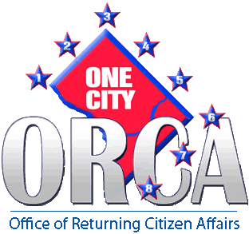

**THE OFFICE ON RETURNING CITIZEN AFFAIRS IS**

**PLEASED TO ANNOUNCE OUR NEW LOCATION**

**Beginning Monday, July 8, 2013 ORCA will be Headquartered at:**

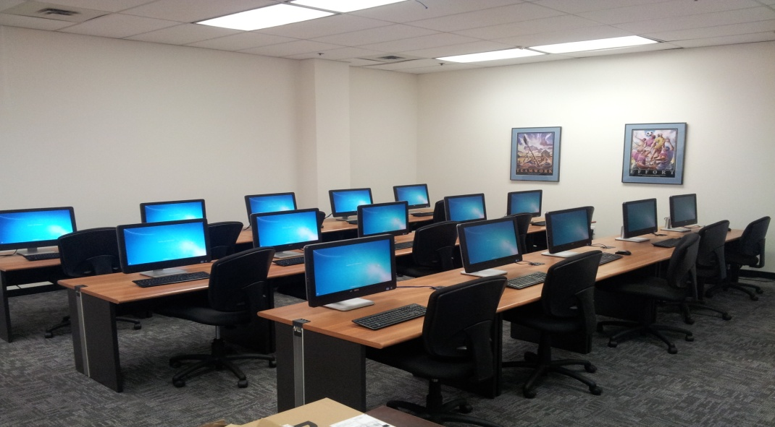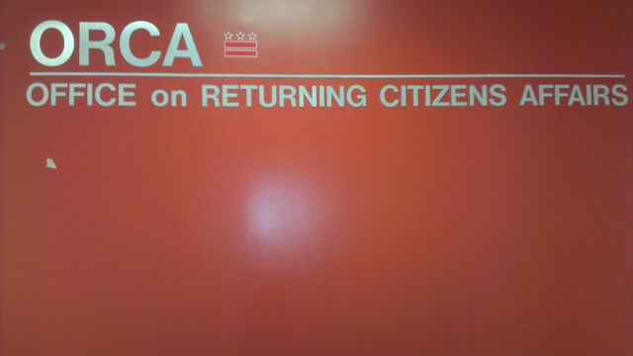

**The** [**Office on Returning Citizen Affairs**](mailto:victor.battle@dc.gov)

[**2100 Martin Luther King Jr. Ave, SE**](mailto:victor.battle@dc.gov)

**Washington, DC 20020**

**Suite 100**

**202-715-7670**